1030_PTR Enrollment initiated by EV for Combo customer
Contract No. 4013670272
Material No. 80010079
Serial No. 25177212
Equipment No. 100002881656
Contract Account. 100047520844
Functional Location. 6002276613
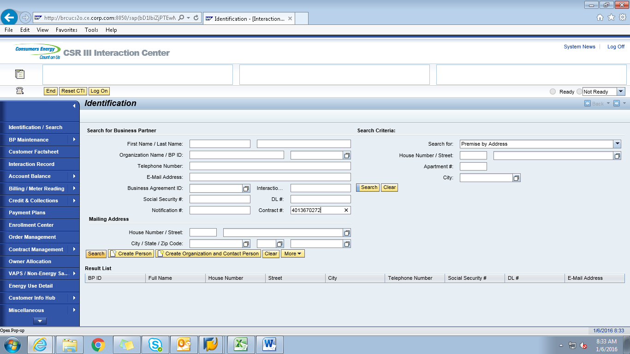

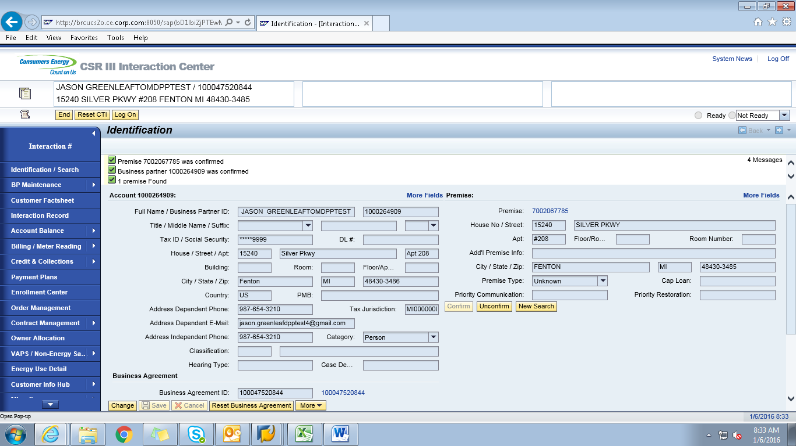
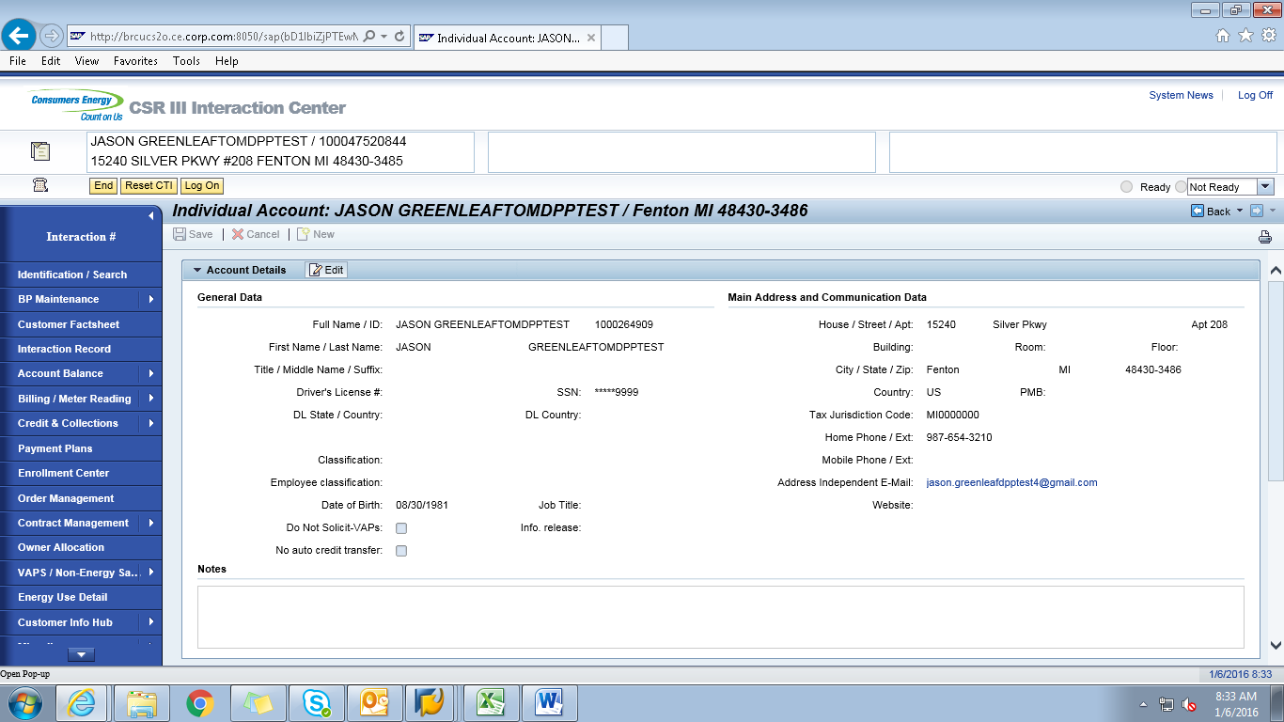

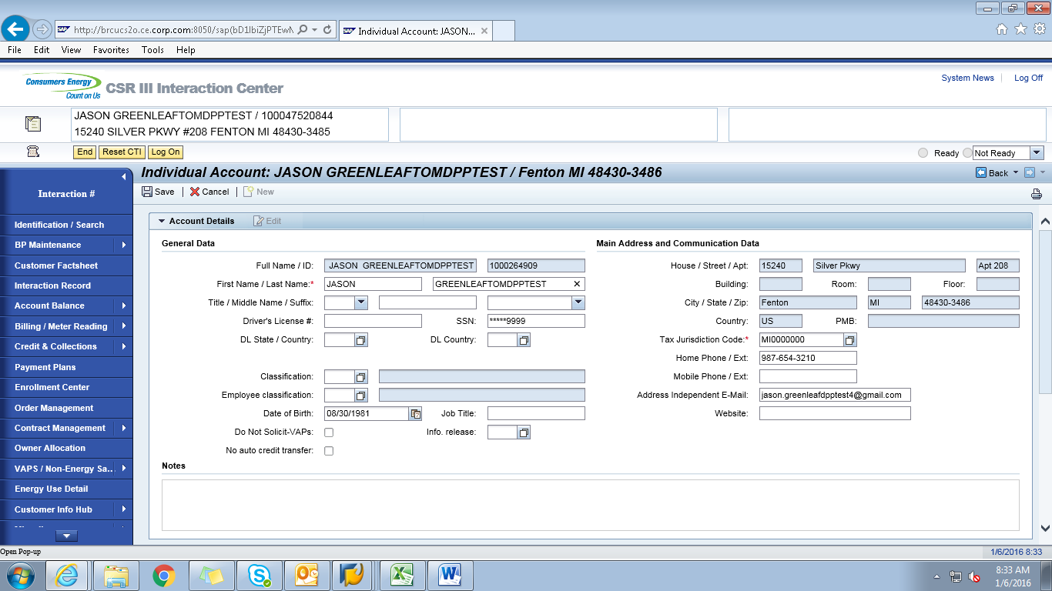

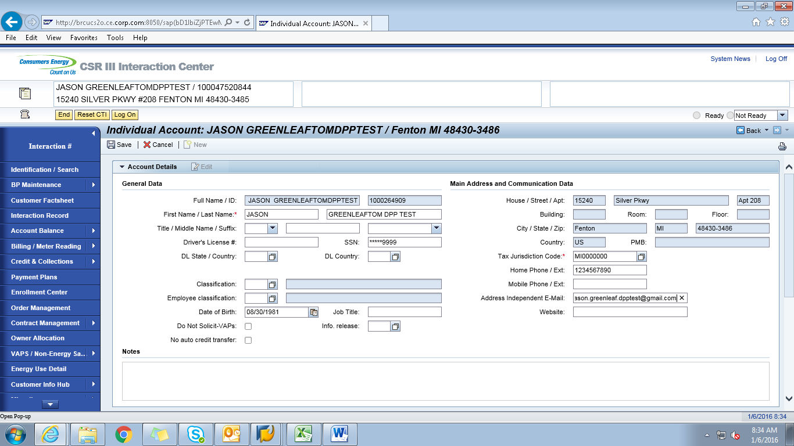

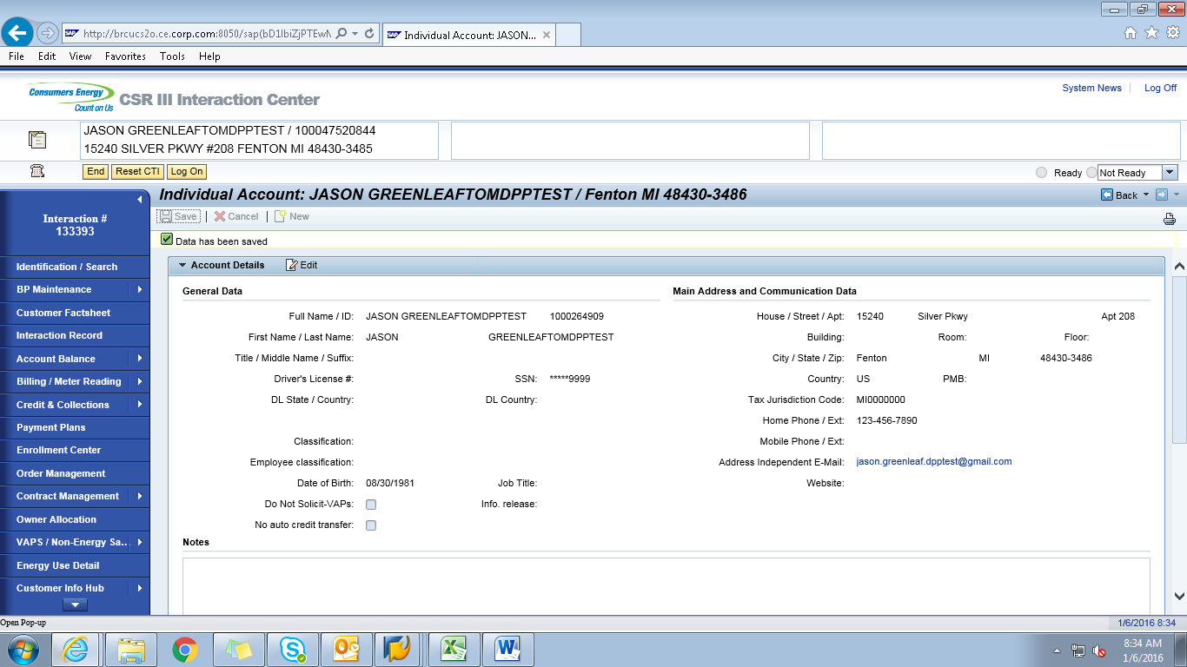

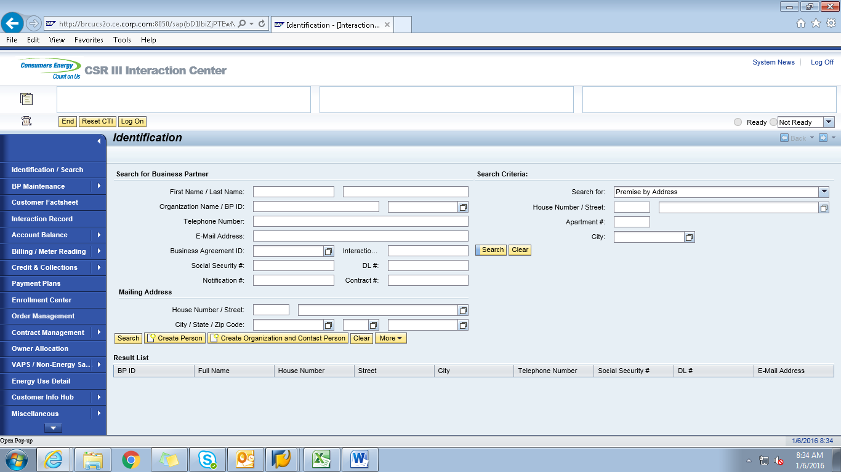

ECC
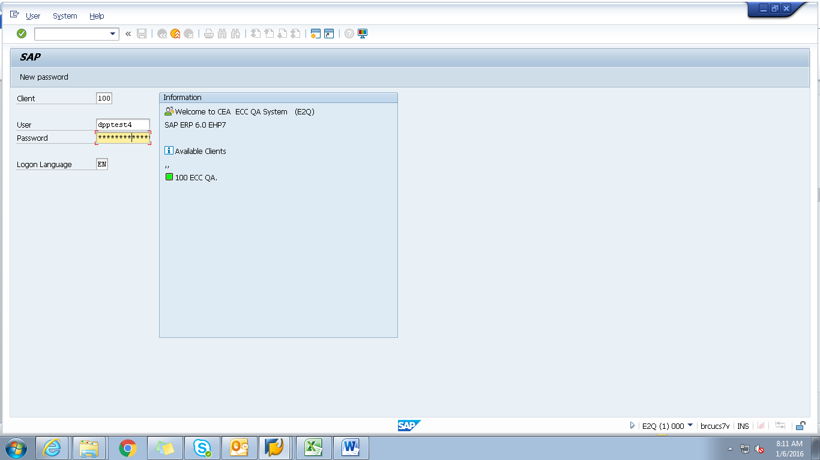

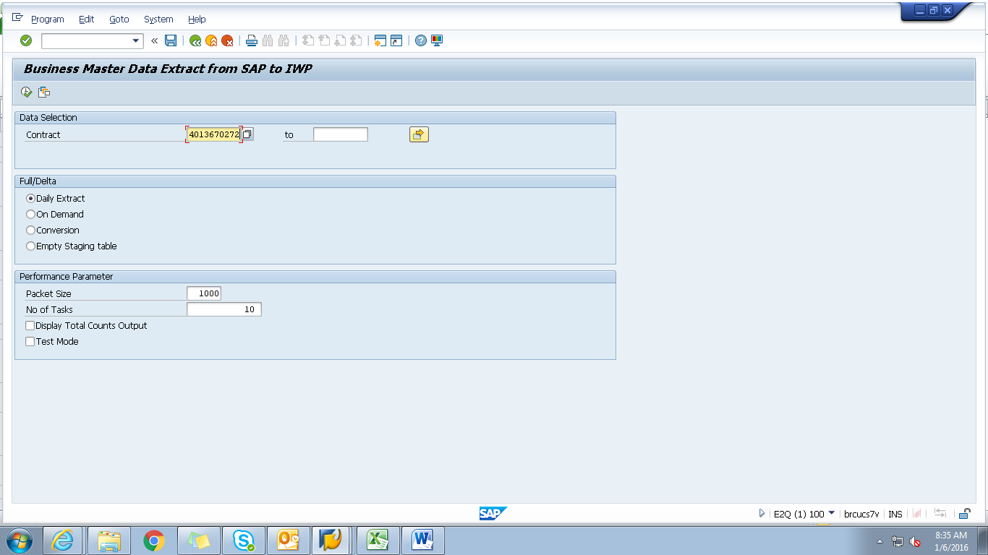

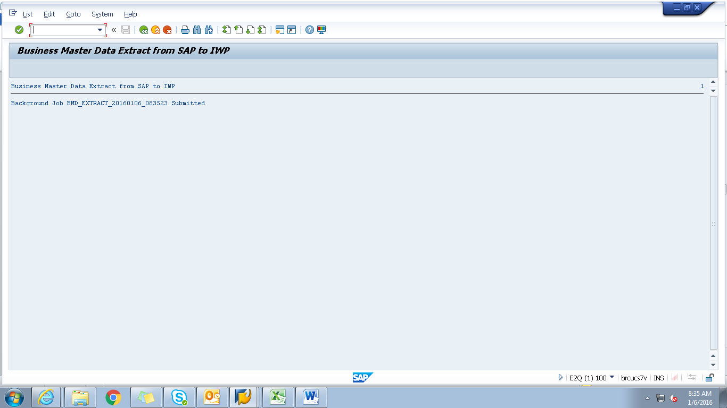
Obj tracking
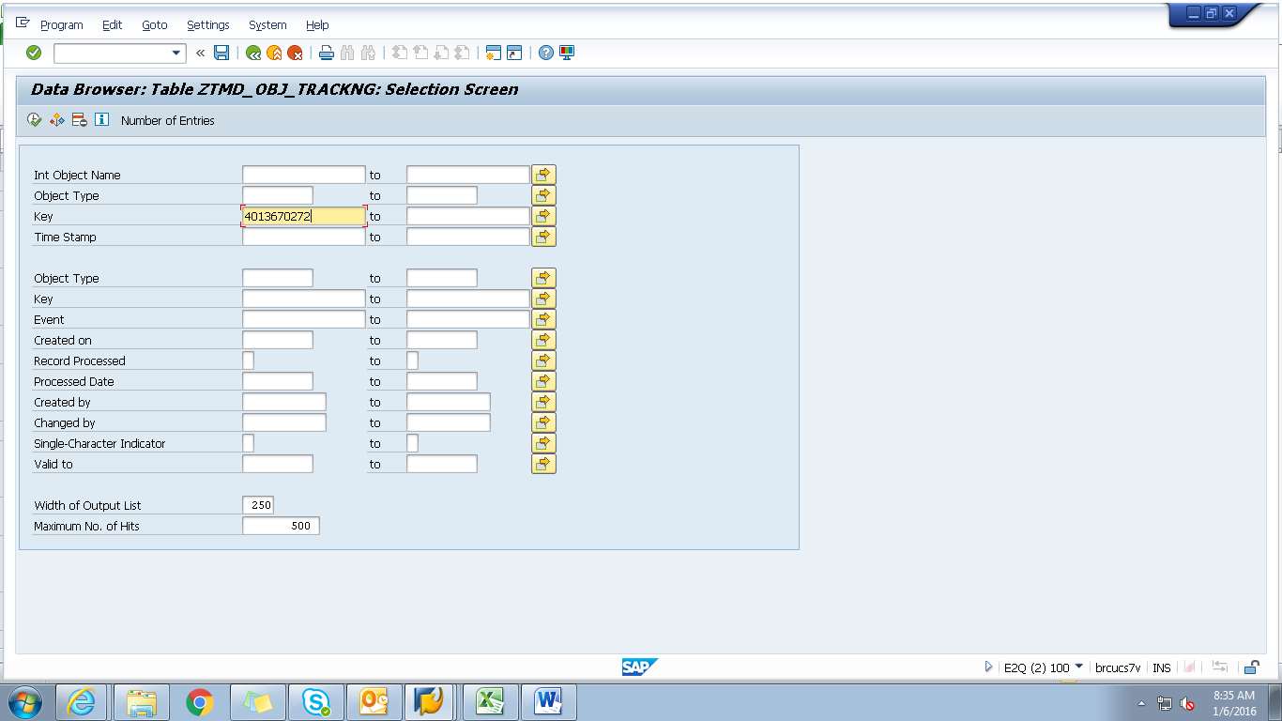
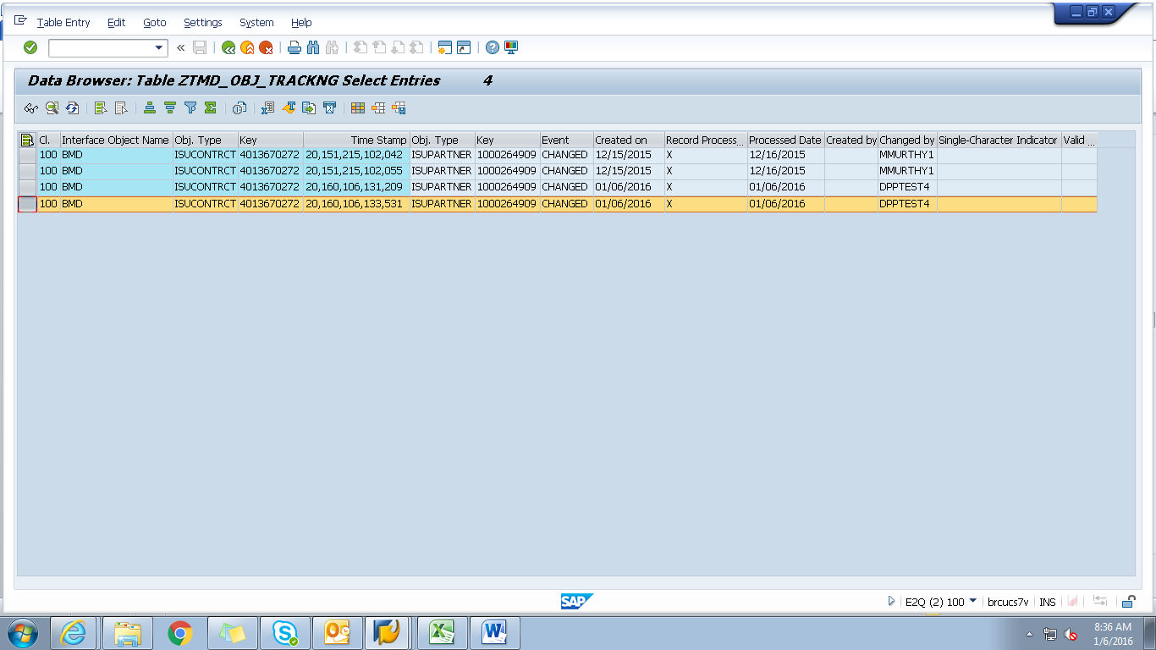
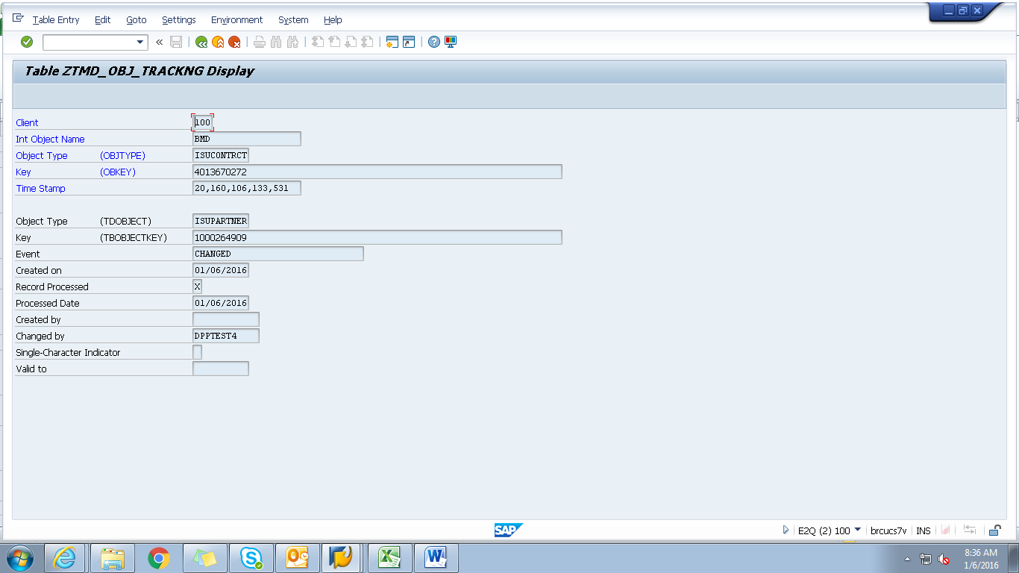
Spool
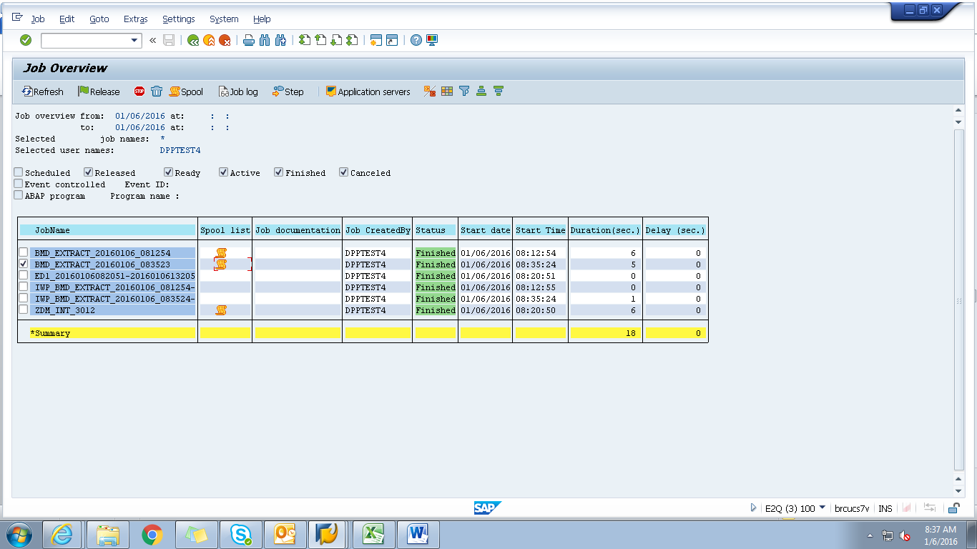

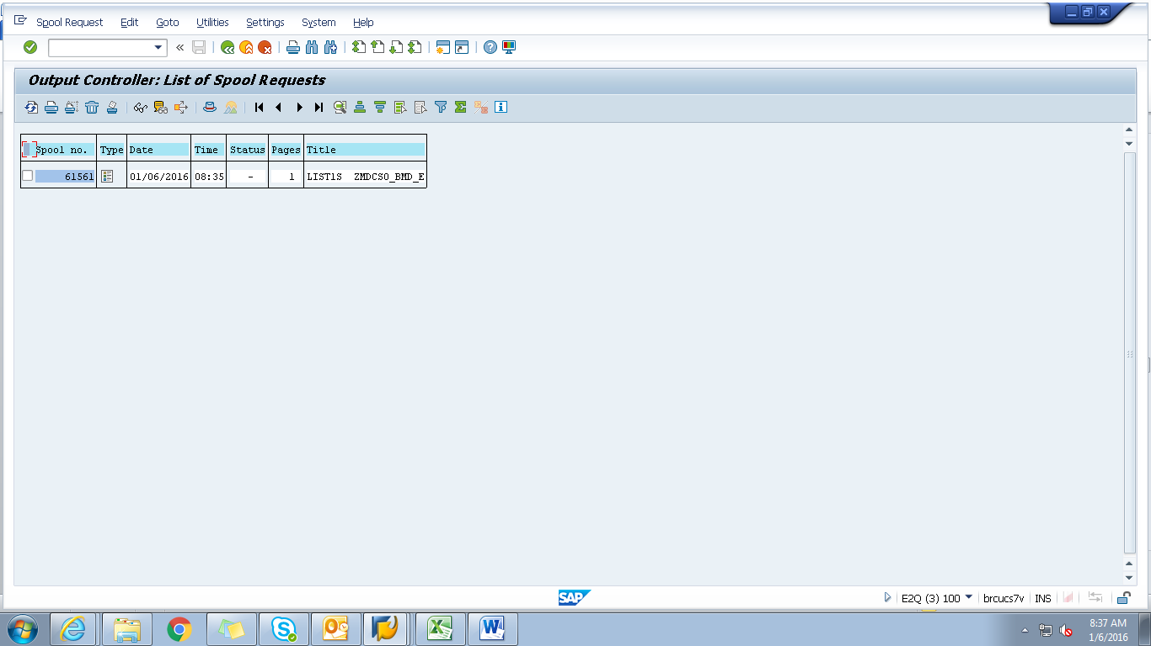

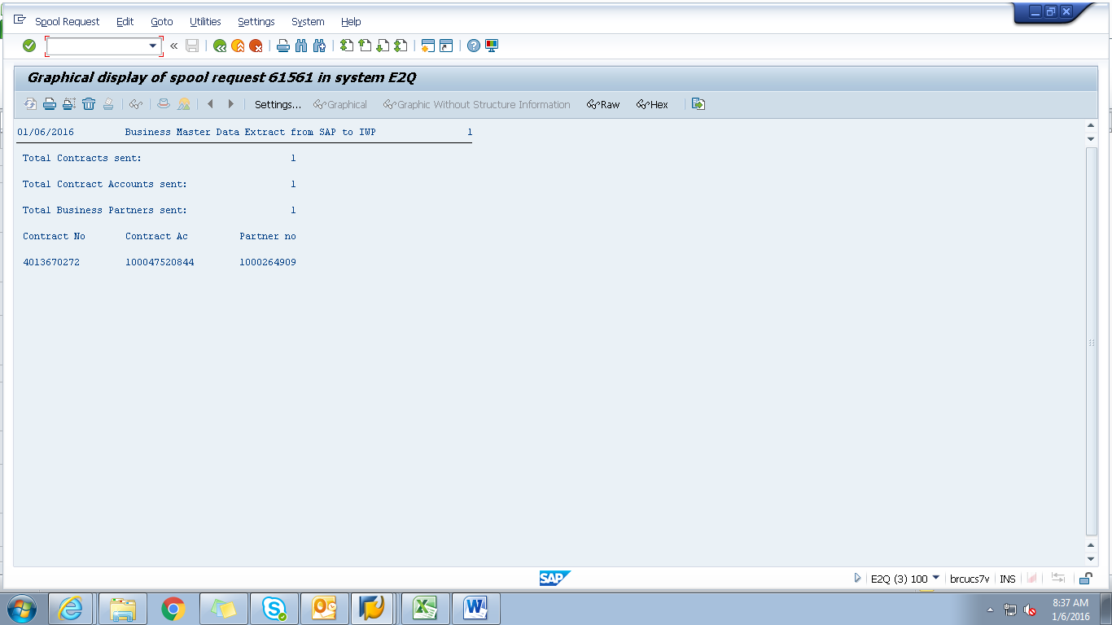

Payload
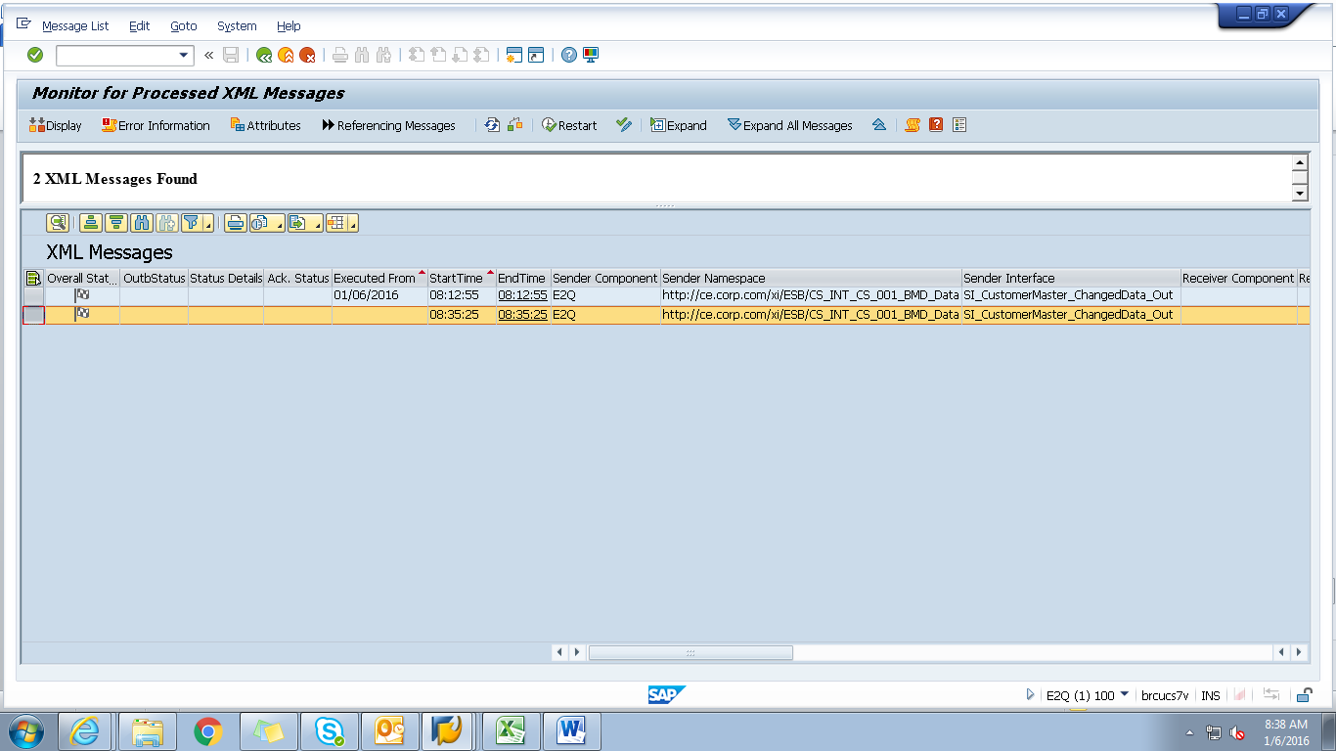

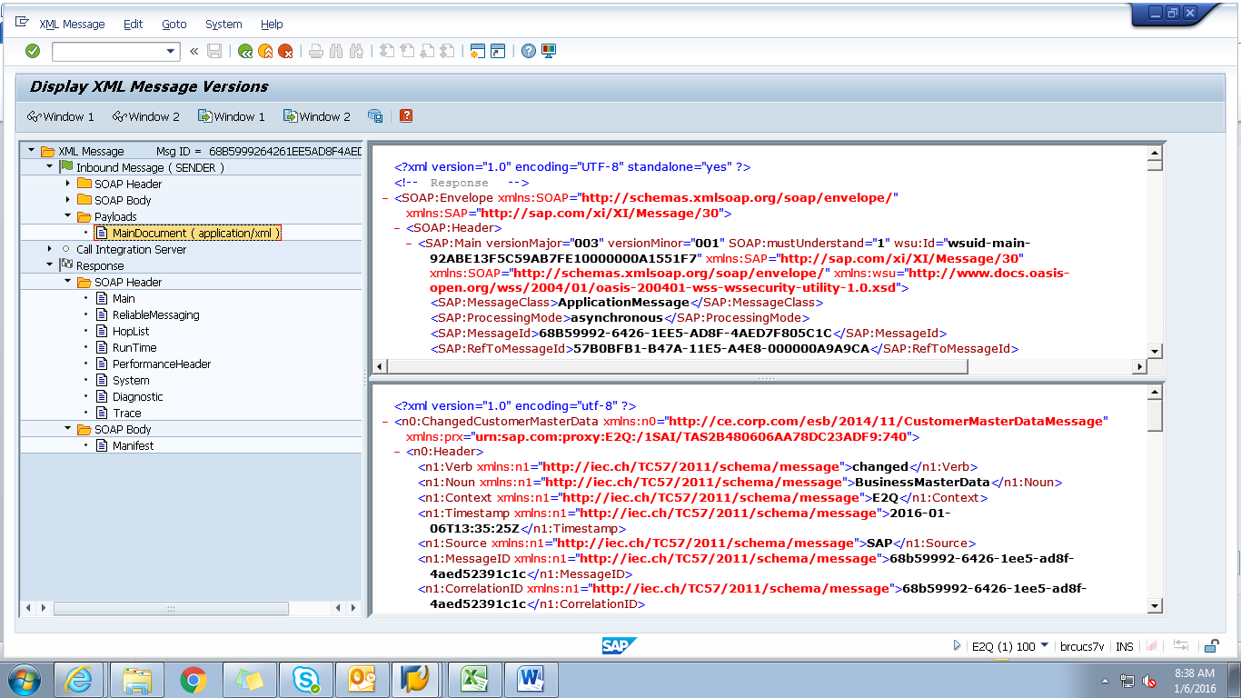

<?xml version="1.0" encoding="utf-8" ?>
- <n0:ChangedCustomerMasterData xmlns:n0="http://ce.corp.com/esb/2014/11/CustomerMasterDataMessage" xmlns:prx="urn:sap.com:proxy:E2Q:/1SAI/TAS2B480606AA78DC23ADF9:740">
- <n0:Header>
<n1:Verb xmlns:n1="http://iec.ch/TC57/2011/schema/message">changed</n1:Verb>
<n1:Noun xmlns:n1="http://iec.ch/TC57/2011/schema/message">BusinessMasterData</n1:Noun>
<n1:Context xmlns:n1="http://iec.ch/TC57/2011/schema/message">E2Q</n1:Context>
<n1:Timestamp xmlns:n1="http://iec.ch/TC57/2011/schema/message">2016-01-06T13:35:25Z</n1:Timestamp>
<n1:Source xmlns:n1="http://iec.ch/TC57/2011/schema/message">SAP</n1:Source>
<n1:MessageID xmlns:n1="http://iec.ch/TC57/2011/schema/message">68b59992-6426-1ee5-ad8f-4aed52391c1c</n1:MessageID>
<n1:CorrelationID xmlns:n1="http://iec.ch/TC57/2011/schema/message">68b59992-6426-1ee5-ad8f-4aed52391c1c</n1:CorrelationID>
- <n1:Property xmlns:n1="http://iec.ch/TC57/2011/schema/message">
<n1:Name>Stereotype</n1:Name>
<n1:Value>CustomerMasterData</n1:Value>
</n1:Property>
</n0:Header>
- <n0:Payload>
- <n2:CustomerMasterData xmlns:n2="http://ce.corp.com/esb/2014/11/CustomerMasterData#">
- <n2:Customer>
<n2:mRID>1000264909</n2:mRID>
<n2:name>JASONGREENLEAFTOMDPPTEST</n2:name>
- <n2:CustomerAccounts>
<n2:mRID>100047520844</n2:mRID>
<n2:createdDateTime>2009-10-28T04:00:00Z</n2:createdDateTime>
<n2:notificationByEmail>true</n2:notificationByEmail>
<n2:paymentTerm>CE21</n2:paymentTerm>
<n2:type>RES</n2:type>
- <n2:CustomerAgreements>
<n2:mRID>4013670272</n2:mRID>
<n2:accountDeterminationID>RT</n2:accountDeterminationID>
<n2:createdDateTime>2009-10-28T04:00:00Z</n2:createdDateTime>
<n2:division>GAS</n2:division>
<n2:rateCategory>A_250</n2:rateCategory>
<n2:startMonth>00</n2:startMonth>
- <n2:Installation>
<n2:mRID>5001966303</n2:mRID>
</n2:Installation>
- <n2:ServiceLocations>
- <n2:UsagePoints>
<n2:mRID>6002276613</n2:mRID>
</n2:UsagePoints>
</n2:ServiceLocations>
- <n2:validityInterval>
<n2:end>9999-12-31T23:59:59Z</n2:end>
<n2:start>2009-11-05T00:00:00Z</n2:start>
</n2:validityInterval>
</n2:CustomerAgreements>
</n2:CustomerAccounts>
- <n2:Indicators>
<n2:type>SENIOR</n2:type>
</n2:Indicators>
- <n2:Indicators>
<n2:type>DLA EXCLUSION</n2:type>
</n2:Indicators>
- <n2:Indicators>
<n2:type>DPP EXCLUSION</n2:type>
</n2:Indicators>
- <n2:Indicators>
<n2:type>DO NOT MARKET</n2:type>
</n2:Indicators>
- <n2:MainAddress>
- <n2:streetDetail>
<n2:buildingName>0024758872</n2:buildingName>
<n2:name>Silver Pkwy</n2:name>
<n2:number>15240</n2:number>
<n2:suiteNumber>Apt 208</n2:suiteNumber>
</n2:streetDetail>
- <n2:townDetail>
<n2:code>48430-3486</n2:code>
<n2:country>US</n2:country>
<n2:name>Fenton</n2:name>
<n2:stateOrProvince>MI</n2:stateOrProvince>
</n2:townDetail>
</n2:MainAddress>
- <n2:Persons>
<n2:firstName>JASON</n2:firstName>
<n2:lastName>GREENLEAFTOMDPPTEST</n2:lastName>
- <n2:electronicAddress>
<n2:email1>jason.greenleaf.dpptest@gmail.</n2:email1>
</n2:electronicAddress>
- <n2:landlinePhone>
<n2:localNumber>123-456-7890-</n2:localNumber>
</n2:landlinePhone>
</n2:Persons>
</n2:Customer>
</n2:CustomerMasterData>
</n0:Payload>
</n0:ChangedCustomerMasterData>

